**Sage**

**SAGE X3 PEOPLE LEAVE REPORTS**

**Technical Design Document**

**PR03 – ZLVECOM – Compassionate Leave – UBA - NIGERIA**

Prepared by Alma Kaltwasser

# Change Record

|  |  |  |  |  |
| --- | --- | --- | --- | --- |
| Date | Author | Version | Change Reference | Naming Convention |
| 27/11/2017 | Alma Kaltwasser | 1.1 | Initial document |  |
|  |  |  |  |  |
|  |  |  |  |  |

# Distribution list

|  |  |  |  |  |
| --- | --- | --- | --- | --- |
| Name | Designated Business Area | Responsibility | Date | Method of Distribution |
|  |  |  |  |  |
|  |  |  |  |  |
|  |  |  |  |  |

# Naming Convention and Definitions

|  |  |
| --- | --- |
| Naming Convention | Definition |
|  |  |
|  |  |
|  |  |

**Contents**

A. Change Record 2

B. Distribution list 2

C. Naming Convention and Definitions 2

1 Executive Summary 4

2 Sample 5

3 Header 7

4 Columns 8

5 Grouping 9

6 Footer 9

7 Output 10

8 Selection 10

9 Totals 10

10 Restrictions 10

# Executive Summary

This technical design specification document is intended to describe the technical details that will be created for the Sage X3 People project for the report highlighted on the introduction page of this document.

In this document we address the intended fields that will be included on the report, as well as explanations for the elements implemented where applicable, restrictions to the report, possible clarification areas which will be documented on a new version of this document and suggestions to accommodate best practise which will by default be included to the TDD and can be removed if the suggestion is not accepted.

The areas covered in this document include:

* ZLVECOM

()

# Sample

The below sample is the expected result as provided by the client**.**

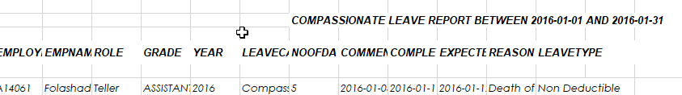

# Header

In the below section, various text and data boxes are required – Where a concatenation of the above is required, the data section of the requirement is specified between square brackets.

Text/Data box 1 - COMPASSIONATE LEAVE REPORT BETWEEN [datedeb] AND [datefin]

# Columns

**EMPLOYEENUMBER**

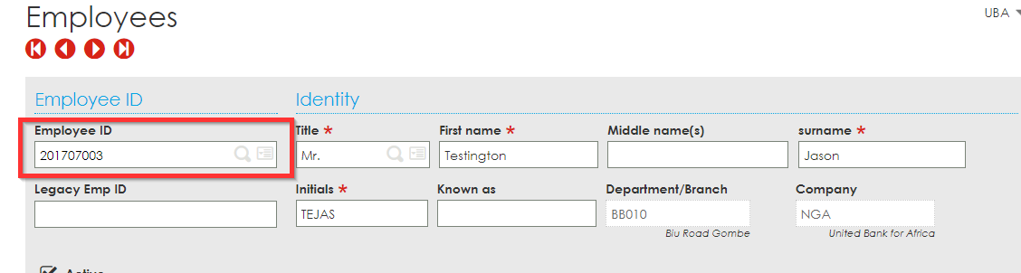

**EMPNAME –** Will be a concatenation of the below two fields, separated with a space.

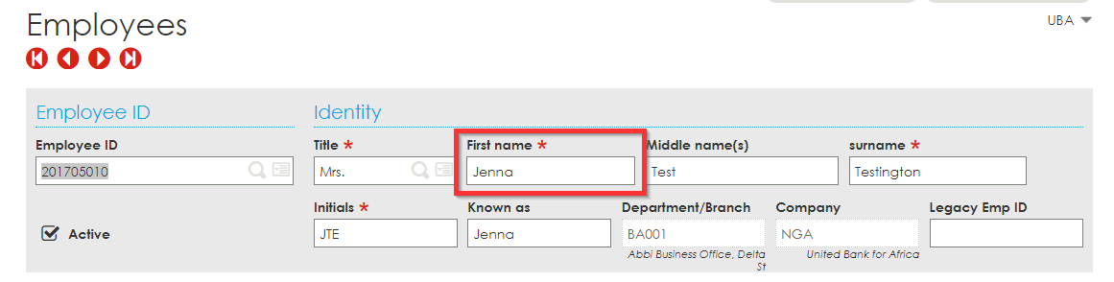

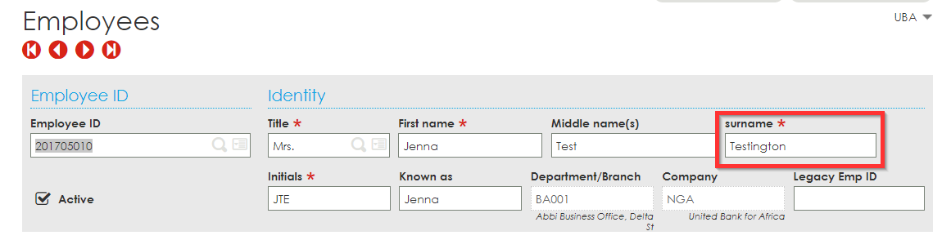

**ROLE**

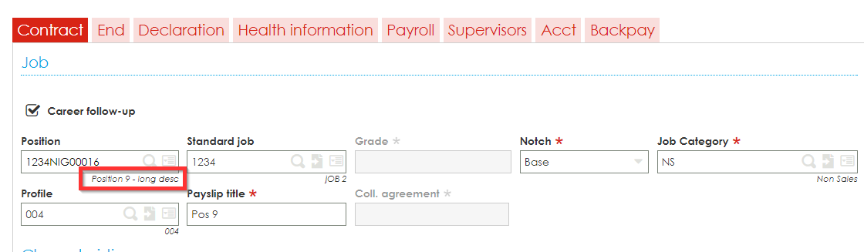

**GRADE**

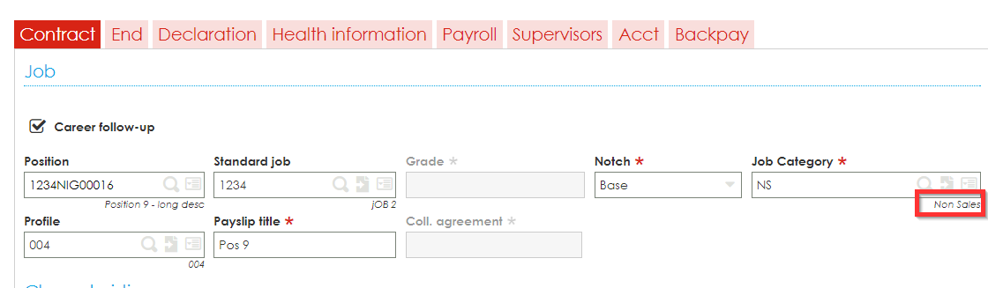

**YEAR**

This field will reflect the year of the leave taken, in instances where the commencement and completion date is in the same year (15 December 2016 – 27 December 2016). E.g: 2016

Where the completion date leaps to a new year, the field will reflect the year of the commencement date, separated by a “/”, and the year of the completion date (15 December 2016 – 03 Jan 2017). E.g: 2016/2017

**LEAVECATEGORY**

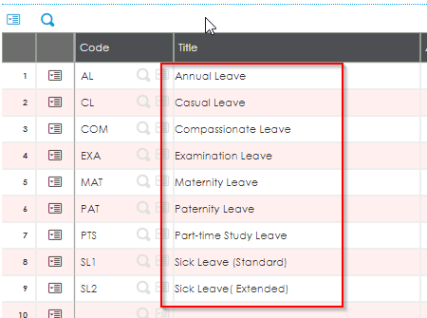

**NOOFDAYS / DAYSTAKEN**

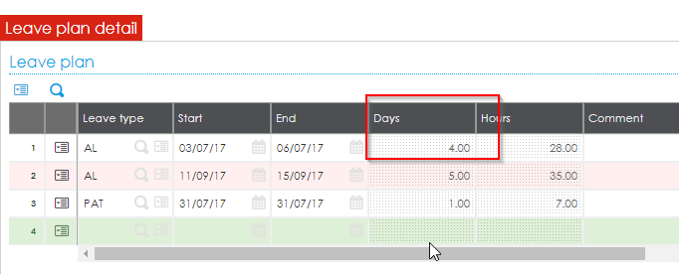

**COMMENCEMENTDATE**

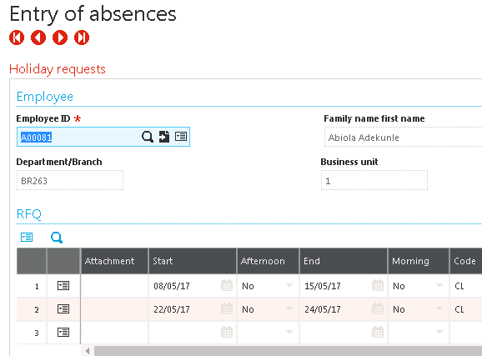

**COMPLETIONDATE**



**EXPECTEDRESUMPTIONDATE**

This would be the End date + 1

**REASON**

This can either be picked up from the entry of absences screen on the leave transaction or on the Portal

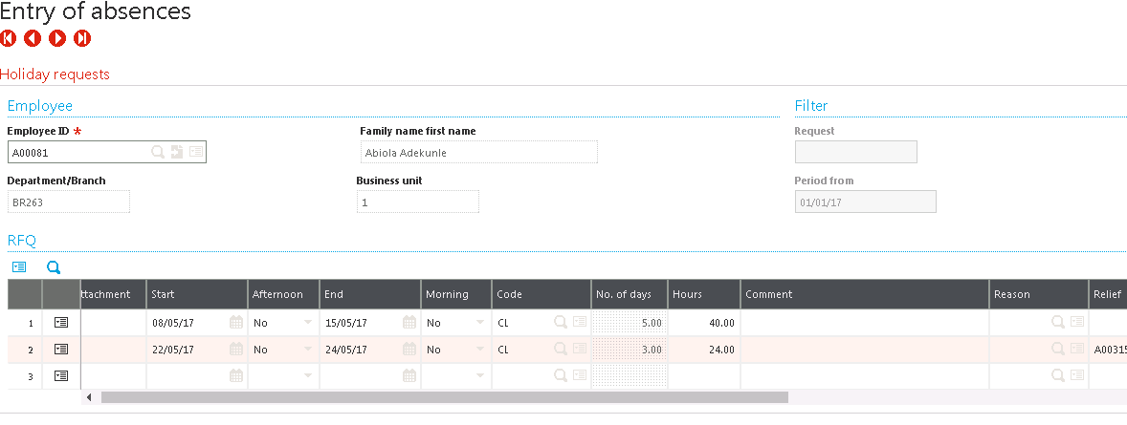

# Grouping

A grouping by employee is required for this report since supplementary payroll “runs” could have an impact on this.

# Footer

# Output

This report will be executed as a crystal report. The report output can be found by going to the following location within sage.

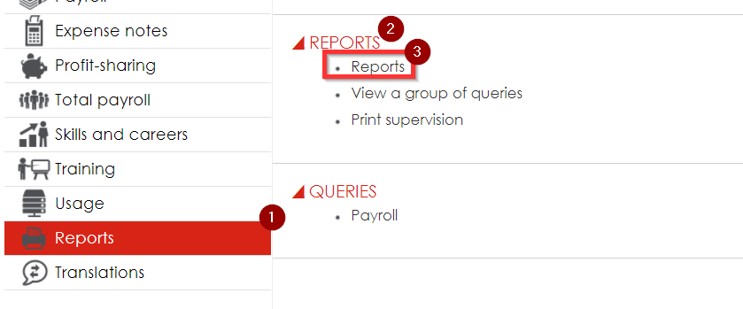

# Selection

The client will have to specify values for the following parameters:

Leave Catergory

Date From

Date To

# Totals

A total for NOOFDAYS are required for this report.

# Restrictions

None